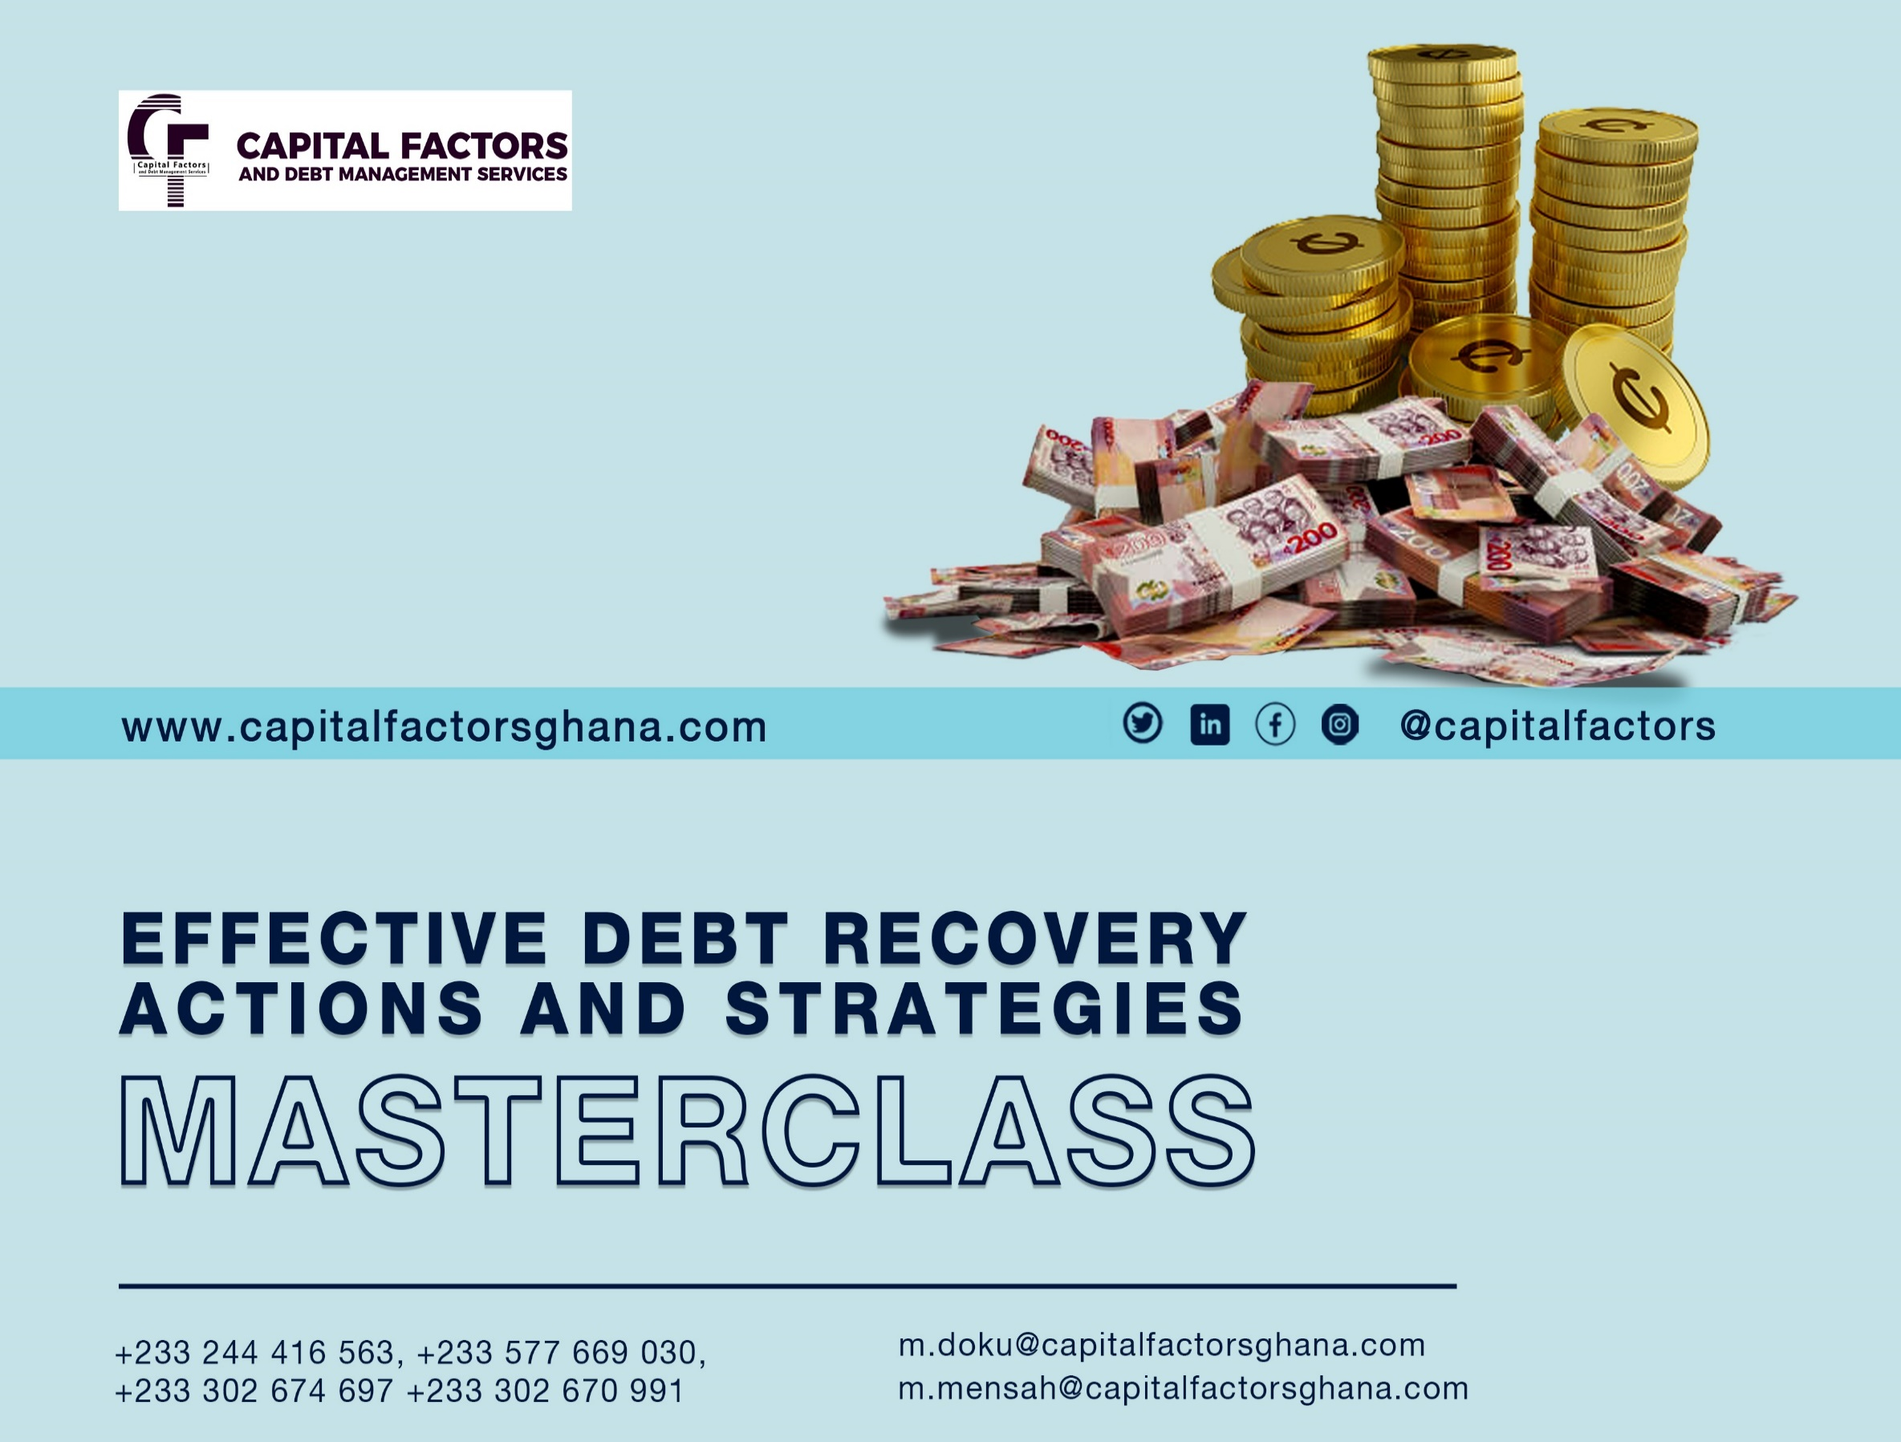
TOPIC “EFFECTIVE DEBT RECOVERY ACTIONS AND STRATEGIES MASTER CLASS”
TIM PAULSEN PROFILE - PRINCIPAL FACILITATOR

About Tim Paulsen:
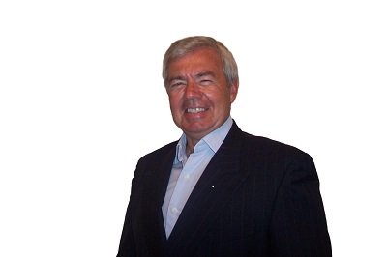
He is the Founder and Managing Director of ICPC, The International Centre for Professional Collections.
In addition to having worked as a collector in both the consumer and commercial fields, Tim has been a credit fraud investigator, collection manager, credit manager and management consultant.
Over the years, he has delivered seminars, consulted with clients and spoken at conferences in 25 different countries.
Tim is the author of several books, including ‘Paid in Full’, ‘The Reluctant Collector’ and ‘How Would Confucius Collect a Past-due Invoice.
He is the creative force behind ‘The Excuse Terminator’ software, used worldwide by thousands of professional collectors, and CIA (Collectability Index Assessment).

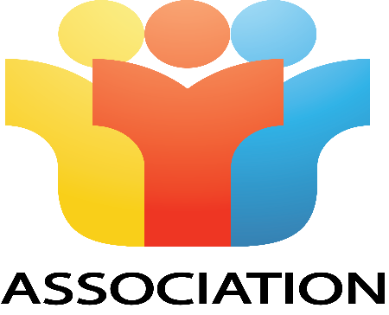

COURSE OVERVIEW
“EFFECTIVE DEBT RECOVERY ACTION AND STRATEGIES MASTER CLASS”
What’s it all about?
Thrive and Survive!
It has never been more crucial for a business to implement a series of effective collection techniques and processes responsibly and ethically to ensure sustainability. By employing effective persuasion and negotiating techniques, a business could improve its bottom line and cash flow, while maximizing recovery on past-due accounts receivables and most importantly, preserving the relationship with customers.
Having trained over 14,000 credit professionals across 6 continents, Tim Paulsen, an internationally sought-after Credit & Collections Specialist, author of such books as ‘Paid in Full’, ‘The Reluctant Collector’, ‘How Would Confucius Collect a Past-Due Invoice’ and ‘Sex, Lies & Negotiation Techniques, will demonstrate a systematic and creative approach in Credit Collect Strategies and Negotiation Skills that will help you accelerate your collection ratio.
Soft Skills? Don’t let the label fool you – they can be difficult to grasp and even hard to put in place and sustain. Tim says that Collections is not for the faint of heart.

MODULES
- Can bad debt be profitable?
- Standards of professional collection.
- Excuse resolution.
- Why you are not being paid.
- The truth, the whole truth and nothing but the truth.
- How to write powerful collection letters and e-mails.
- Mastering the three phases of a collection – whether is a call or a personal visit.
- Deal with difficult customers, including irate and worse.
- Develop a special collection voice, easier to understand and more compelling.
- Negotiation jiujitsu – how to disarm your opponent.
- How to become a strategic negotiator.
- Eight essential differences between effective and average negotiators.
- Know the five approaches to negotiate – and most importantly, when to deploy them to your advantage.
- How to recognise and take advantage of choice points in your collection negotiation.
- Saving face - yours and your opponents.
- Twenty key elements of platinum negotiations (from Tim’s book of the same – in development)
- Hire, manage and develop a team of collection professionals

Who Should Attend?
- You collect delinquent invoices or accounts from consumers or commercial accounts.

- Your responsibility includes training team members to improve their skills and performance in accounts receivables.

- You are responsible for the supervision or management of Accounts Receivables in your organization.

- Past participants who have rated these programs high have ranged from accounts receivables representatives to Credit Managers and Vice-Presidents of Finance & Administration.

- You may be in a supervisory or management position, responsible for a receivables portfolio but are rarely called upon to contact or converse with a debtor. Why are some of the specific collection techniques important to you?
- You are willing to work hard and contribute during the program. Tim says the program is not only content-rich, but it is also highly participative with no passengers – only crew.
Why Attend?
Simply put, you want to collect more money, faster and where possible, keep your hard-earned customers.
Many firms spend time and effort to train and develop the members of sales, service and marketing. Often the last to get attention, if at all, are the people who work in accounts receivable,
We find this to be a head-shaking situation because these are the same people who are responsible for the most liquid asset after cash!
Whether on location or via webinars, Tim Paulsen, author and International Specialist in Creative Receivables Management will demonstrate effective methods to help you and your organization collect more money, quicker...and still keep your customers. Tim says, “The effective loan is not complete until the money has been paid AND the Customer returns to deal with you again AND pays on time in the future!"
“Collections is collections”, Tim says, adding that, “there are general principles that apply whether one is collecting a personal debt from a friend or a brother-in-law to a large amount from a corporate client.
However, there are differences within professions, countries and cultures. These ‘differences’ may not allow a successful technique in North America to be used South of the Equator. An approach that works well in Singapore, may not be as effective when dealing with a client in Hong Kong or Mumbai.”
The objective of this highly participative program is to ensure the attendees develop a systematic approach to one of their firm’s largest liquid assets after cash - tailored to their individual needs.
Tim’s workshops are highly participative and designed to stimulate your thinking, inspire your creativity and enhance your productivity. As such, minimum but meaningful concept inputs will be shared followed by discussions, case studies and designated role play on how you can practice these techniques in your Credit Collection strategies.
Group exercises and presentations will be very much to the fore, No passengers in this course – crew only!
Tim says,’ come ready to work hard – and have fun!

BENEFITS
- Some of the target participants are likely to be decision-makers in their respective organizations and may influence a business deal with your organization in future
- Networking
TARGET PARTICIPANTS
- Branch Officers / Managers
- Branch Loan Managers/ Officers
- Recovery Coordinators
- Recovery Supervisors /Officers
- Operations Officers / Supervisors
- Sales Staff
A two-sessional two-day “EFFECTIVE DEBT RECOVERY ACTIONS AND STRATEGIES MASTER CLASS” Training Program will be Six (6) hours each day.
The Resource Persons will deliver their topics via lectures, discussions, and case studies exercises, and a Question-and-Answer session will be held.
DATE : 12th – 13th SEPTEMBER, 2022 (SESSION 1)
OR
15th – 16th SEPTEMBER, 2022 (SESSION 2)
TRAINING FEE : GHC 1,500.00 VAT Exclusive
TIME : 09:00 AM
VENUE : The New Capital Group Limited Training Centre
PACKAGE : Course Materials, Certificate, Coffee Break and Lunch
………………………………………………………………………………………………………………………….
Kindly complete this form and detach it. We will call back on you to pick it up.

Name of Contact Person……………………………………………………
Telephone Number:…………………………………………………………
Name of Organization:……………………………………………………...
NO. Of Participants to Attend:………………………………………………
Signature :
Date :

After completing the form kindly send the detached registration form to mailto:info@ccifranceghana.com

